**Resize or changing the type of EBS:**

* We have to create a snapshot from a volume. Then create a volume from snapshot and increase the size or change the type while doing that as below.

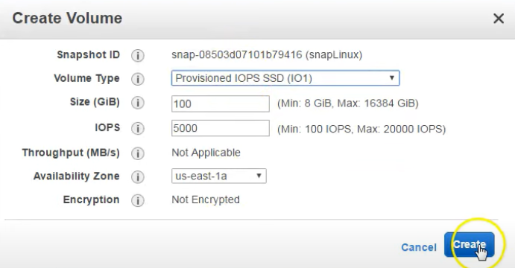

* This is the old method. Now amazon gave us an option to change the volume type or size without creating the snapshot.
* Right click on volume and select modify volume option.

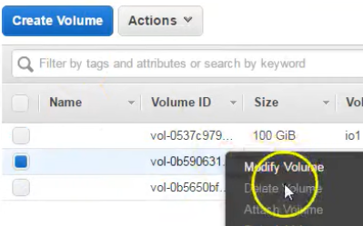

* Then we can change the type and size as below.

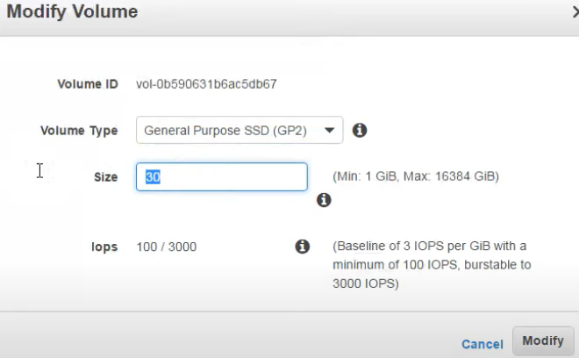

* This may take some time and we also need to increase the file system size in OS level.

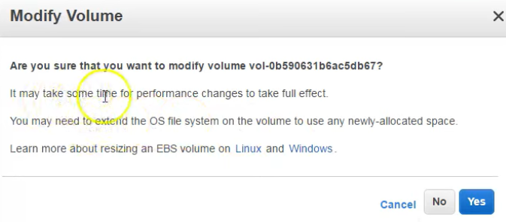

**Size of volume can only be increased but not decreased as below.**

